HotelPOS: Hotel Restaurant Point-of-Sale and Order Management System
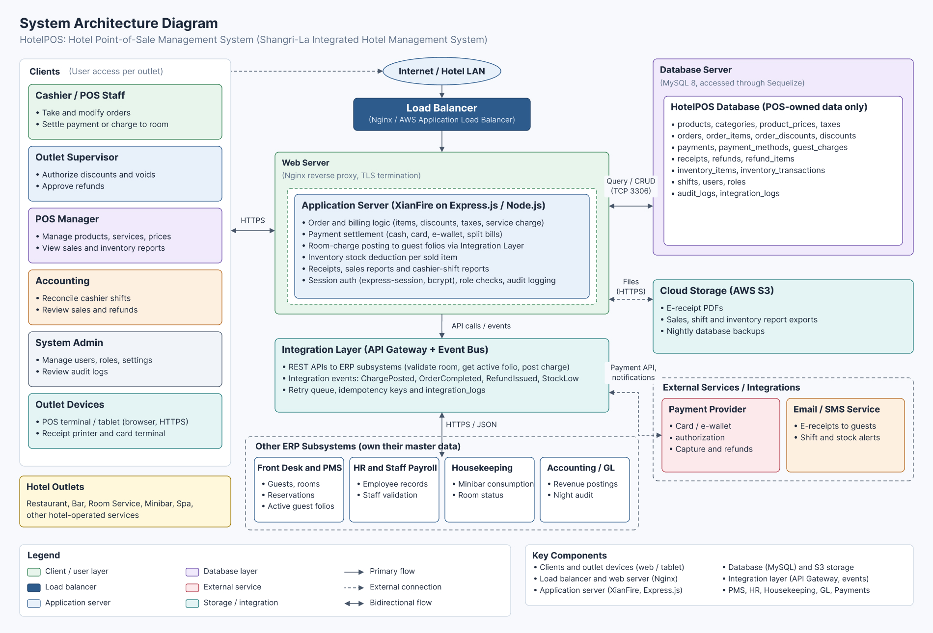
Figure 1: System Architecture Diagram
The system architecture shows how the HotelPOS subsystem reaches its users and how it fits inside the Shangri-La Integrated Hotel Management System. Cashiers and POS staff, outlet supervisors, POS managers, accounting and system administrators use POS terminals, tablets, receipt printers and card terminals in the hotel outlets: the restaurant, bar, room service, minibar, spa and other hotel-operated services. Traffic passes the Internet or hotel LAN and a load balancer (Nginx or an AWS Application Load Balancer) to the web server, which hosts the application server built on the XianFire framework (Express.js on Node.js). The application server holds the order and billing logic, payment settlement, room-charge posting, inventory deduction, receipts and reports, and session-based authentication with role checks and audit logging.
The HotelPOS database (MySQL 8, accessed through Sequelize) stores only POS-owned data: products, prices, orders, order items, payments, guest charges, receipts, refunds, inventory transactions, shifts, audit logs and integration logs. Guest, room, reservation and folio data stay in the Front Desk and PMS, and employee data stays in HR and Staff Payroll. The POS reaches these ERP subsystems, together with Housekeeping and Accounting/GL, through an Integration Layer (API gateway and event bus). E-receipts, report exports and backups go to cloud storage (AWS S3), while a payment provider and an email/SMS service are external integrations.
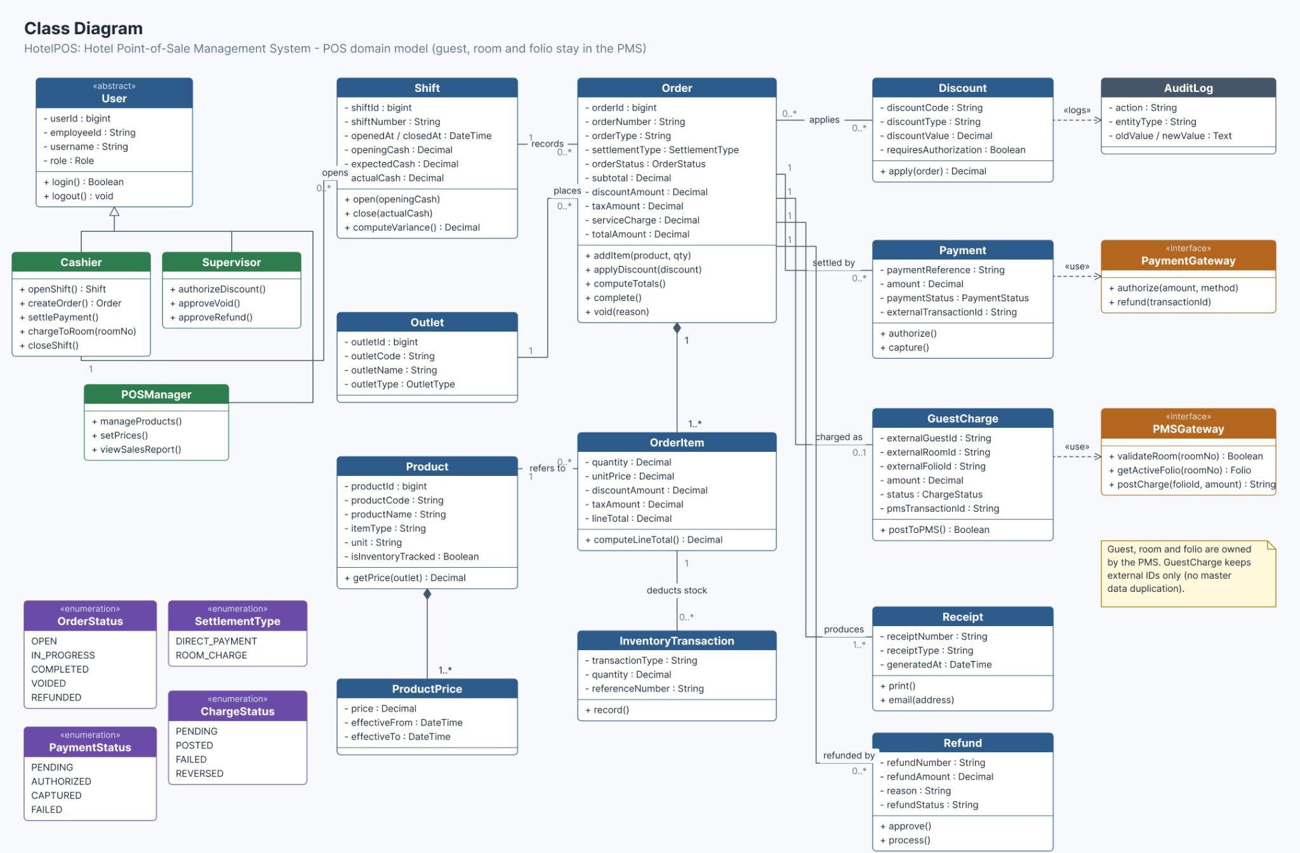
Figure 2: Class Diagram
The class structure is the back-end blueprint of HotelPOS, since each class mirrors a role or record that the point-of-sale process handles. The abstract User class (userId, employeeId, username, role, login(), logout()) is specialized by Cashier (openShift, createOrder, settlePayment, chargeToRoom, closeShift), Supervisor (authorizeDiscount, approveVoid, approveRefund) and POSManager (manageProducts, setPrices, viewSalesReport). A Cashier opens a Shift, which records many Orders, and each Order is placed at an Outlet.

An Order is composed of one or more OrderItems, each referring to a Product whose prices are kept in ProductPrice. An Order may apply Discounts, be settled by Payments, be charged as a GuestCharge, produce Receipts and be refunded by Refunds, while each OrderItem deducts stock through an InventoryTransaction. The enumerations OrderStatus, SettlementType, ChargeStatus and PaymentStatus define the allowed values. GuestCharge uses the PMSGateway interface (validateRoom, getActiveFolio, postCharge) and Payment uses the PaymentGateway interface. GuestCharge keeps only external guest, room and folio IDs, so no PMS master data is duplicated.

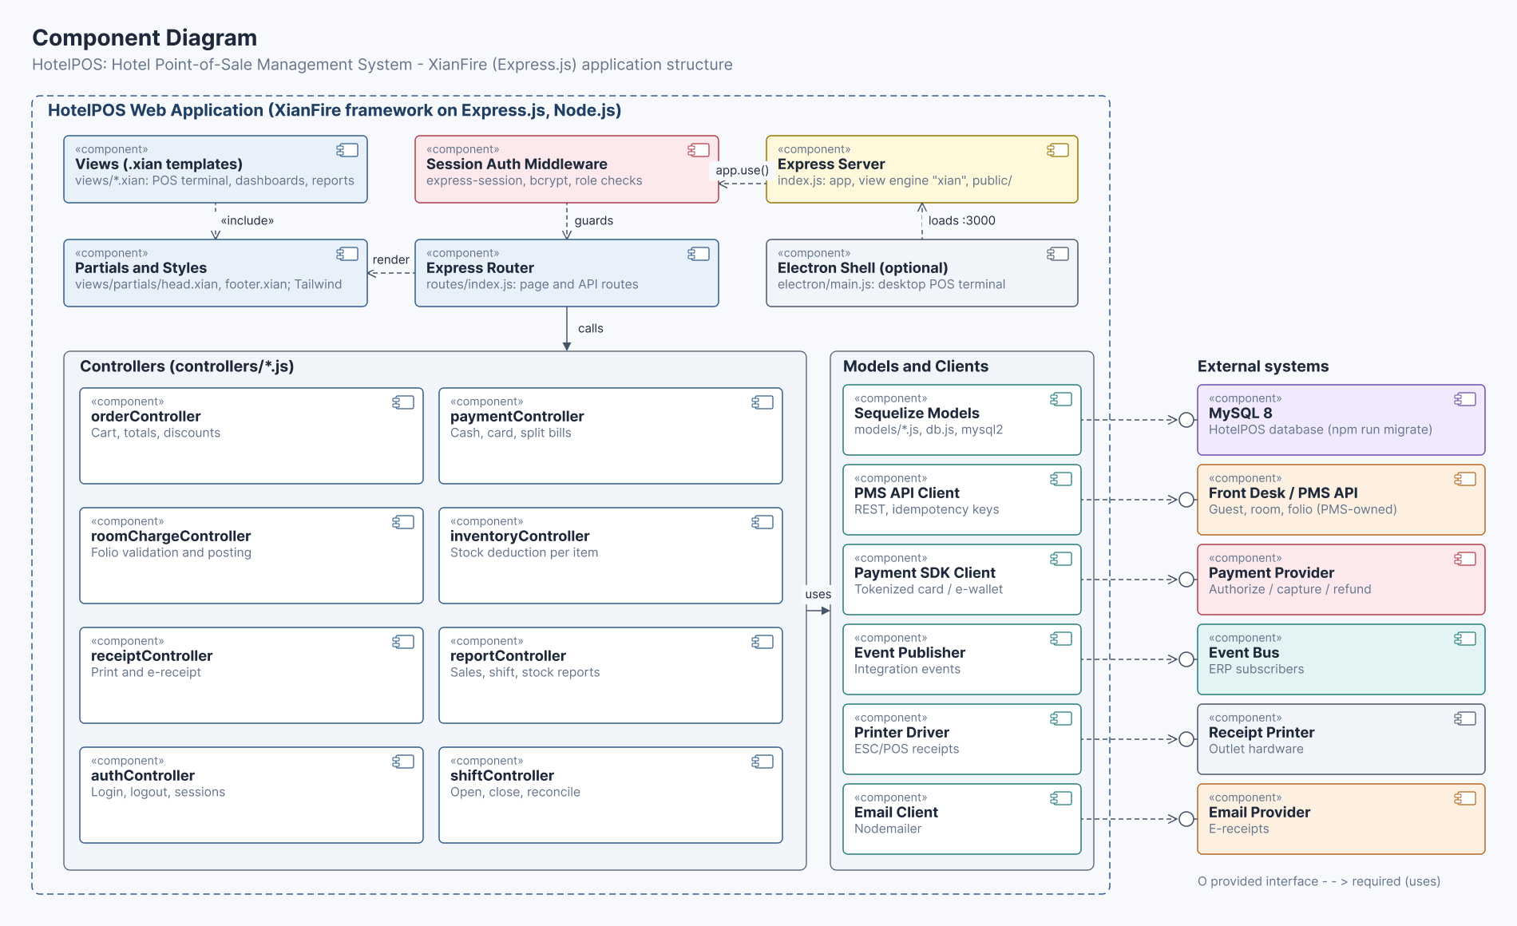
Figure 3: Component Diagram
The component structure shows how the HotelPOS application is organized in the XianFire framework and how its parts depend on one another. The Express Server (index.js) sets up the app, the "xian" view engine and the public folder, and mounts the Session Auth Middleware (express-session, bcrypt, role checks). The middleware guards the Express Router (routes/index.js), which renders the .xian views (POS terminal, dashboards, reports) and their partials (head.xian, footer.xian, Tailwind). An optional Electron shell (electron/main.js) can run the POS as a desktop terminal app.

The router calls the controllers: order, payment, roomCharge, inventory, receipt, report, auth and shift. The controllers use the models and clients: Sequelize models (models/*.js, db.js, mysql2) for the MySQL database, the PMS API client for the Front Desk and PMS, the payment SDK client for the payment provider, the event publisher for the event bus, the printer driver for receipt printers and the email client (Nodemailer) for e-receipts. Each external system is reached through its provided interface.

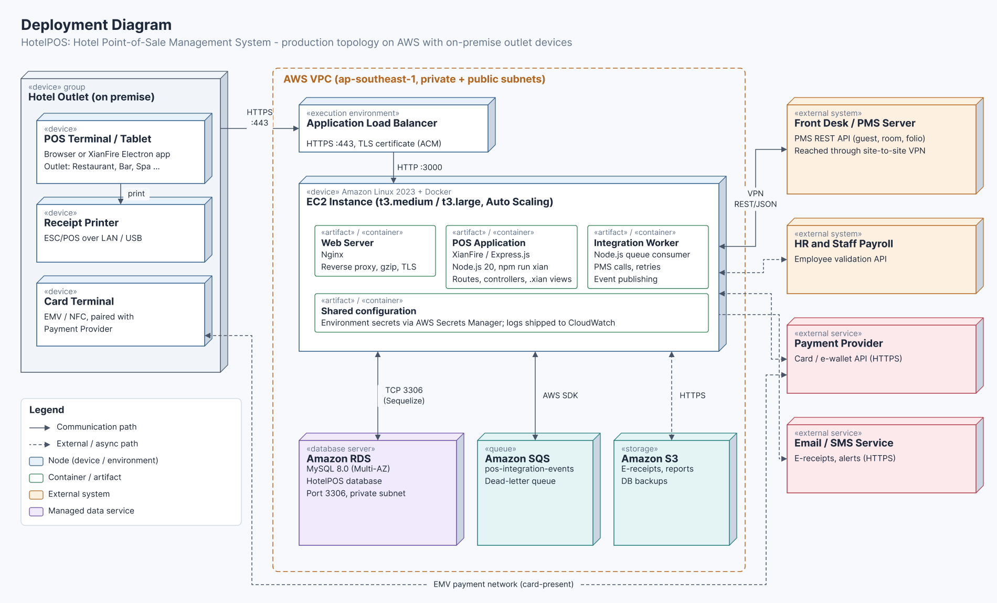
Figure 4: Deployment Diagram
The deployment setup connects the HotelPOS software to the infrastructure that runs it, and guides the work needed to run the system in production. In each hotel outlet, a POS terminal or tablet (a browser or the XianFire Electron app), a receipt printer (ESC/POS over LAN or USB) and a card terminal (EMV/NFC) form the on-premise device group. The terminals connect over HTTPS (port 443) to an AWS VPC, where an Application Load Balancer forwards requests on port 3000 to an EC2 instance (t3.medium or t3.large, auto scaling optional).
The EC2 instance runs three Docker containers: the Nginx web server, the POS application (XianFire on Express.js, Node.js 20, started with npm run xian) and an integration worker that handles PMS calls, retries and event publishing. MySQL 8.0 runs on Amazon RDS (Multi-AZ) and is reached over the private network on port 3306 through Sequelize. Amazon SQS holds integration events with a dead-letter queue, and Amazon S3 keeps e-receipts, reports and backups. The Front Desk/PMS server is reached through a site-to-site VPN, while HR and Staff Payroll, the payment provider and the email/SMS service are external systems.

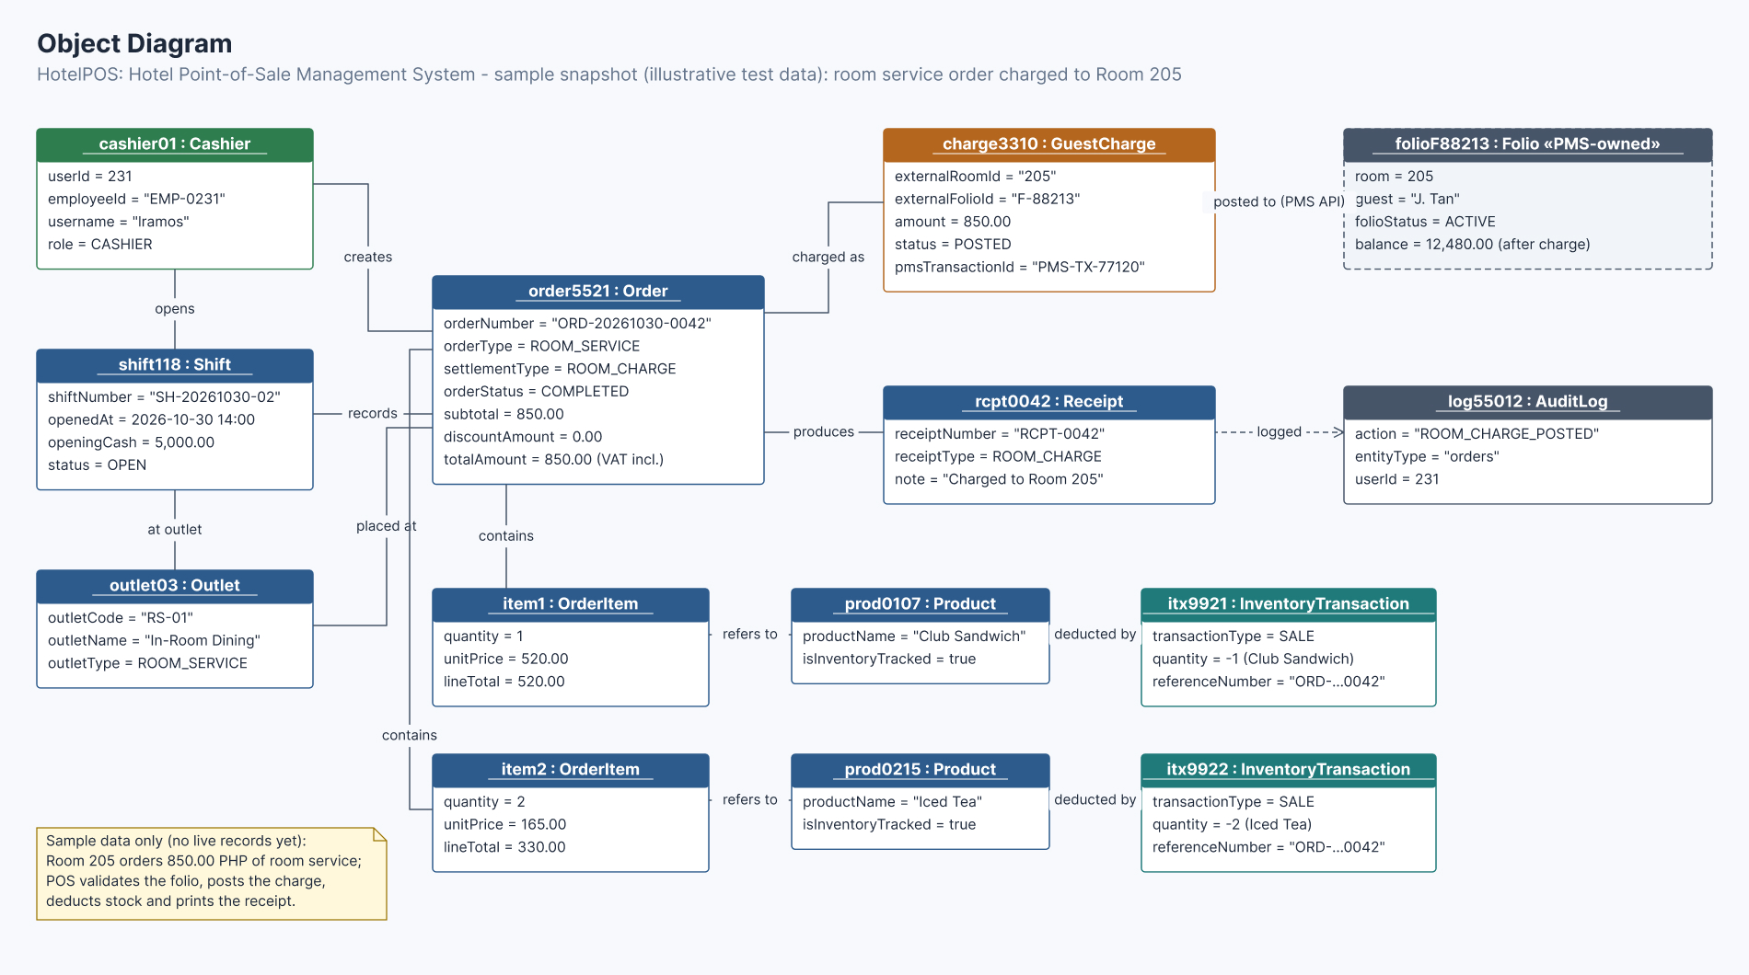
Figure 5: Object Diagram
The object snapshot ties the HotelPOS classes to sample transaction data based on the Room 205 example in the system description, which helps verify data structures during test scenarios. cashier01 (EMP-0231, role CASHIER) opens shift118 (SH-20261030-02, opening cash 5,000.00) at outlet03 (RS-01, In-Room Dining, ROOM_SERVICE). The cashier creates order5521 (ORD-20261030-0042), a room-service order with settlement type ROOM_CHARGE, status COMPLETED and a total of 850.00 VAT inclusive. The order contains item1 (one Club Sandwich at 520.00) and item2 (two Iced Teas at 165.00), and each item's stock is deducted by an inventory transaction (itx9921, itx9922).
The order is charged as charge3310 (room 205, folio F-88213, amount 850.00, status POSTED, PMS transaction PMS-TX-77120), which is posted through the PMS API to folioF88213, a PMS-owned folio for guest J. Tan. The order also produces rcpt0042, a ROOM_CHARGE receipt marked "Charged to Room 205", which is logged as log55012 (ROOM_CHARGE_POSTED). All values are illustrative test data, since the system has no live records yet, and should be replaced with actual records once the system is in use.

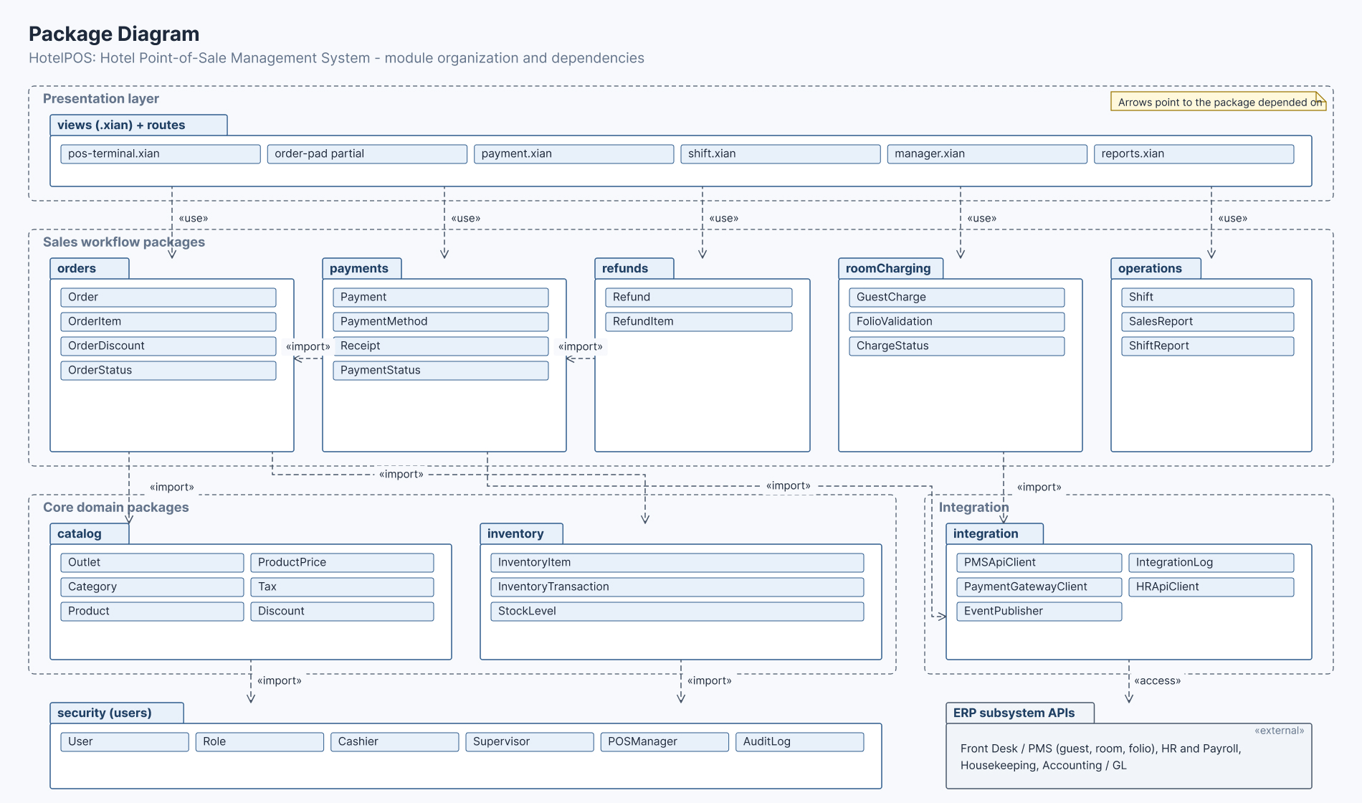
Figure 6: Package Diagram
The package structure organizes the HotelPOS classes into modules, so the sales workflow, catalog, inventory and integration code stay separate and easy to maintain. The presentation layer holds the views (.xian) and routes package: pos-terminal.xian, the order-pad partial, payment.xian, shift.xian, manager.xian and reports.xian. The sales workflow packages are orders (Order, OrderItem, OrderDiscount, OrderStatus), payments (Payment, PaymentMethod, Receipt, PaymentStatus), refunds (Refund, RefundItem), roomCharging (GuestCharge, FolioValidation, ChargeStatus) and operations (Shift, SalesReport, ShiftReport).
The core domain packages are catalog (Outlet, Category, Product, ProductPrice, Tax, Discount) and inventory (InventoryItem, InventoryTransaction, StockLevel). The integration package (PMSApiClient, PaymentGatewayClient, EventPublisher, IntegrationLog, HRApiClient) accesses the external ERP subsystem APIs, and security holds User, Role, Cashier, Supervisor, POSManager and AuditLog. Dependencies run downward: the views use every workflow package, refunds import payments, payments import orders, orders import catalog and inventory, payments and roomCharging import integration, and catalog and inventory import security.

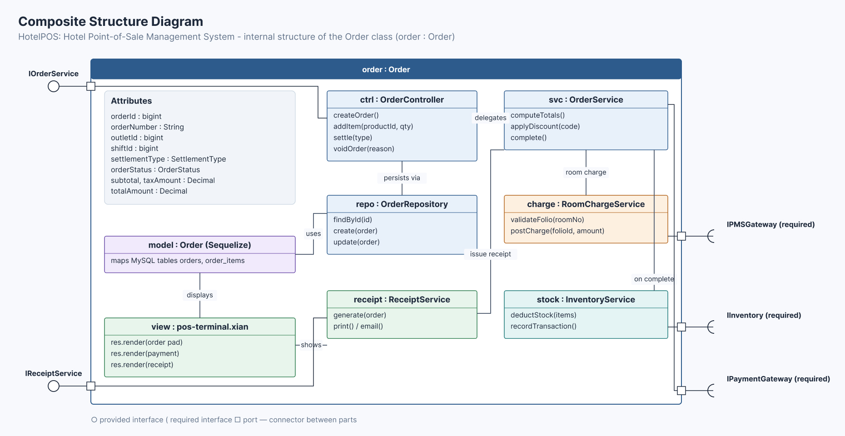
Figure 7: Composite Structure Diagram
The Order class sits at the center of HotelPOS because every sale, room charge, receipt and stock movement depends on it, so its internal structure is opened up here (order : Order). It holds the attributes orderId, orderNumber, outletId, shiftId, settlementType, orderStatus, subtotal, taxAmount and totalAmount. Its parts are OrderController (createOrder, addItem, settle, voidOrder), OrderService (computeTotals, applyDiscount, complete), OrderRepository (findById, create, update), the Order Sequelize model mapped to the orders and order_items tables, RoomChargeService (validateFolio, postCharge), InventoryService (deductStock, recordTransaction), ReceiptService (generate, print, email) and the pos-terminal.xian view.
Connectors show that the controller delegates to the service and persists through the repository, which uses the model, while the view displays the model and shows receipts. The service calls RoomChargeService for room charges, InventoryService when the order completes and ReceiptService to issue a receipt. The class provides two interfaces, IOrderService and IReceiptService, and requires three: IPMSGateway, IInventory and IPaymentGateway.

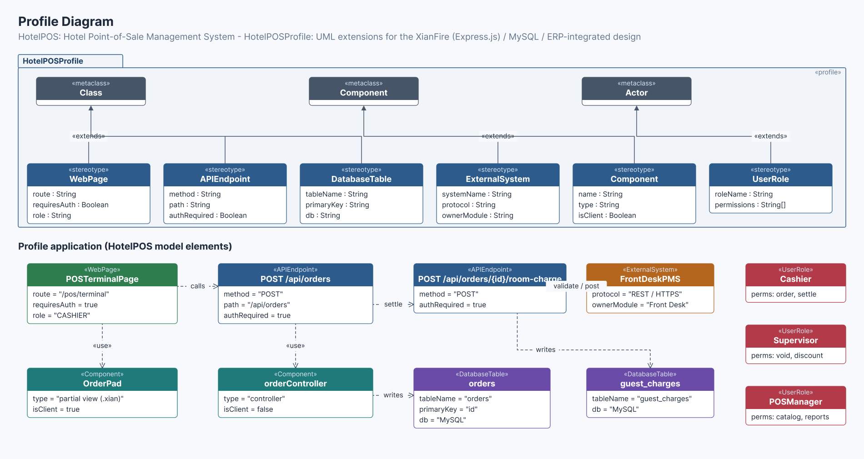
Figure 8: Profile Diagram
The HotelPOSProfile customizes UML for the project's XianFire (Express.js) and MySQL design and its ERP integration, so pages, endpoints, tables, external systems, components and roles are modeled in one consistent vocabulary. It defines six stereotypes: WebPage (route, requiresAuth, role), APIEndpoint (method, path, authRequired) and DatabaseTable (tableName, primaryKey, db), which extend the Class metaclass; ExternalSystem (systemName, protocol, ownerModule) and Component (name, type, isClient), which extend Component; and UserRole (roleName, permissions), which extends Actor.
The lower part applies to them. POSTerminalPage (/pos/terminal, role CASHIER) uses the OrderPad partial view and calls POST /api/orders, which uses orderController to write the orders table in MySQL. Settling an order calls POST /api/orders/{id}/room-charge, which validates and posts through the FrontDeskPMS external system (REST over HTTPS, owned by Front Desk) and writes the guest_charges table. The Cashier, Supervisor and POSManager roles carry the permissions for ordering and settling, voids and discounts, and catalog and reports.

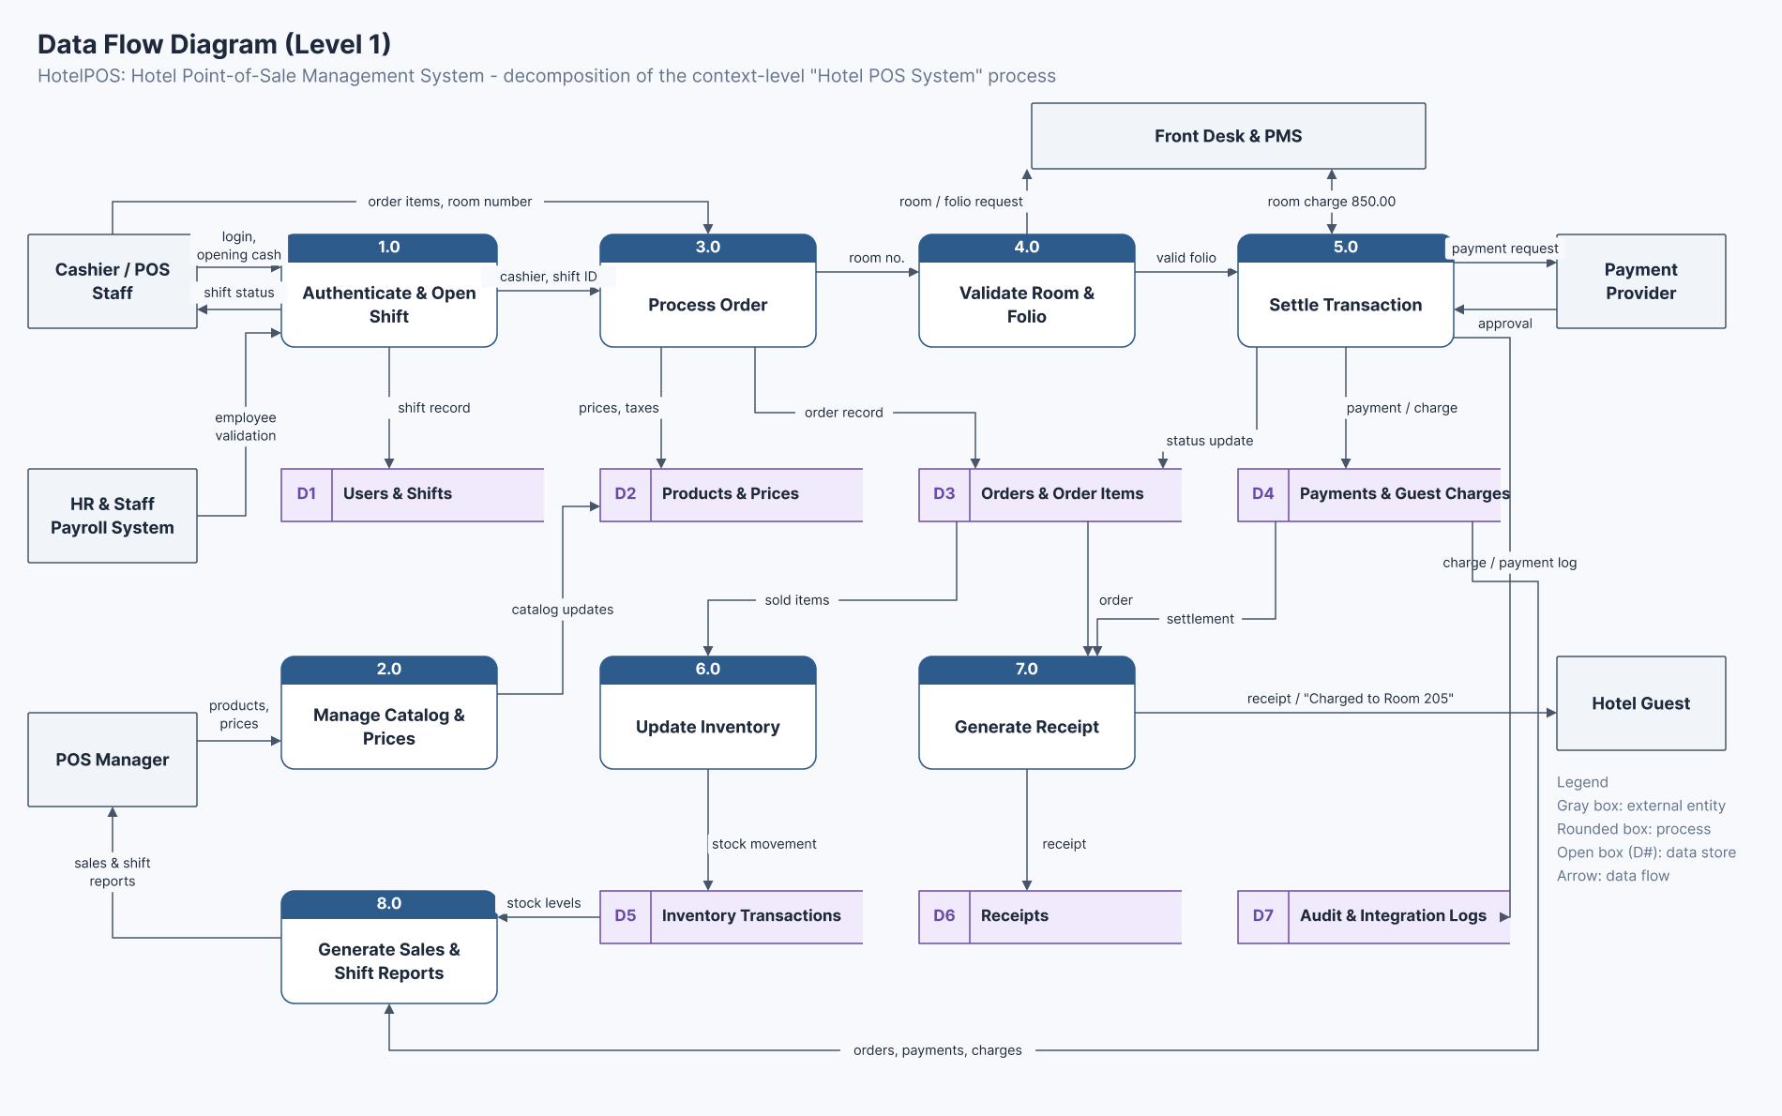
Figure 9: Data Flow Diagram (Level 1)
The Level 1 data flow breaks the context-level Hotel POS System process into eight processes and traces how data moves between them. The external entities are the Cashier/POS Staff, POS Manager, HR and Staff Payroll System, Front Desk and PMS, Payment Provider and Hotel Guest. 1.0 Authenticate and Open Shift receives login and opening cash, validates the employee with HR and writes D1 Users and Shifts. 3.0 Process Order receives the order items and room number, reads prices from D2 Products and Prices and writes D3 Orders and Order Items. 4.0 Validate Room and Folio sends the room and folio request to the PMS.
5.0 Settle Transaction posts the 850.00 room charge to the PMS or sends a payment request to the payment provider, writes D4 Payments and Guest Charges, updates the order status in D3 and logs the result in D7 Audit and Integration Logs. 2.0 Manage Catalog and Prices takes product and price updates from the POS Manager into D2. 6.0 Update Inventory reads sold items from D3 and writes D5 Inventory Transactions. 7.0 Generate Receipt reads D3 and D4, writes D6 Receipts and gives the guest a receipt marked "Charged to Room 205". 8.0 Generate Sales and Shift Reports reads D4 and D5 and returns reports to the POS Manager.

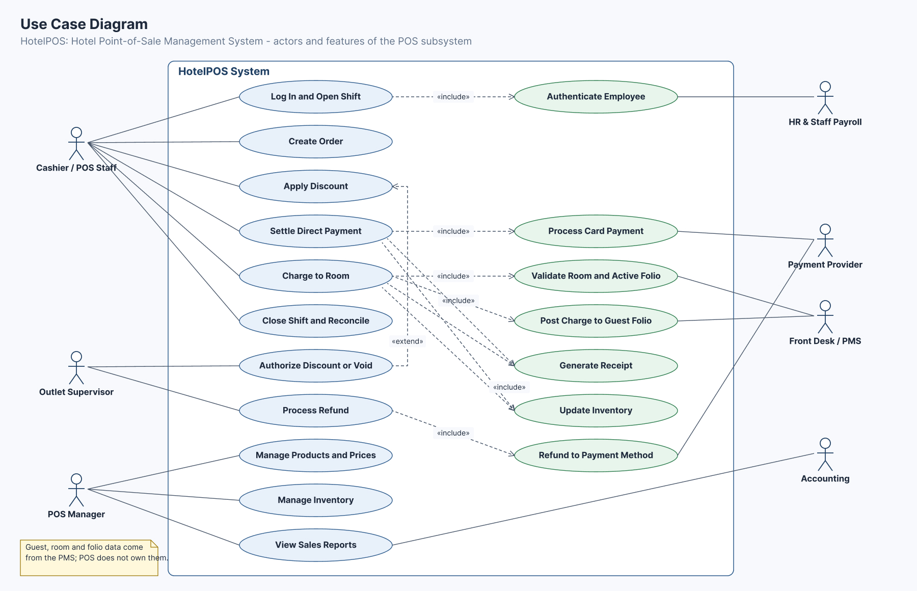
Figure 10: Use Case Diagram
The use cases define the scope of the HotelPOS subsystem and show which actor handles each feature. The Cashier/POS Staff can log in and open a shift, create an order, apply a discount, settle a direct payment, charge to room, and close the shift and reconcile. Logging in includes Authenticate Employee with HR and Staff Payroll. Settling a direct payment includes Process Card Payment with the payment provider. Charging to room includes Validate Room and Active Folio and Post Charge to Guest Folio, both with the Front Desk/PMS. Both settlement use cases include Generate Receipt and Update Inventory.
The Outlet Supervisor handles Authorize Discount or Void, which extends Apply Discount, and Process Refund, which includes Refund to Payment Method through the payment provider. The POS Manager manages products and prices, manages inventory and views sales reports, which Accounting also uses. Guest, room and folio data come from the PMS, so the POS does not own them.

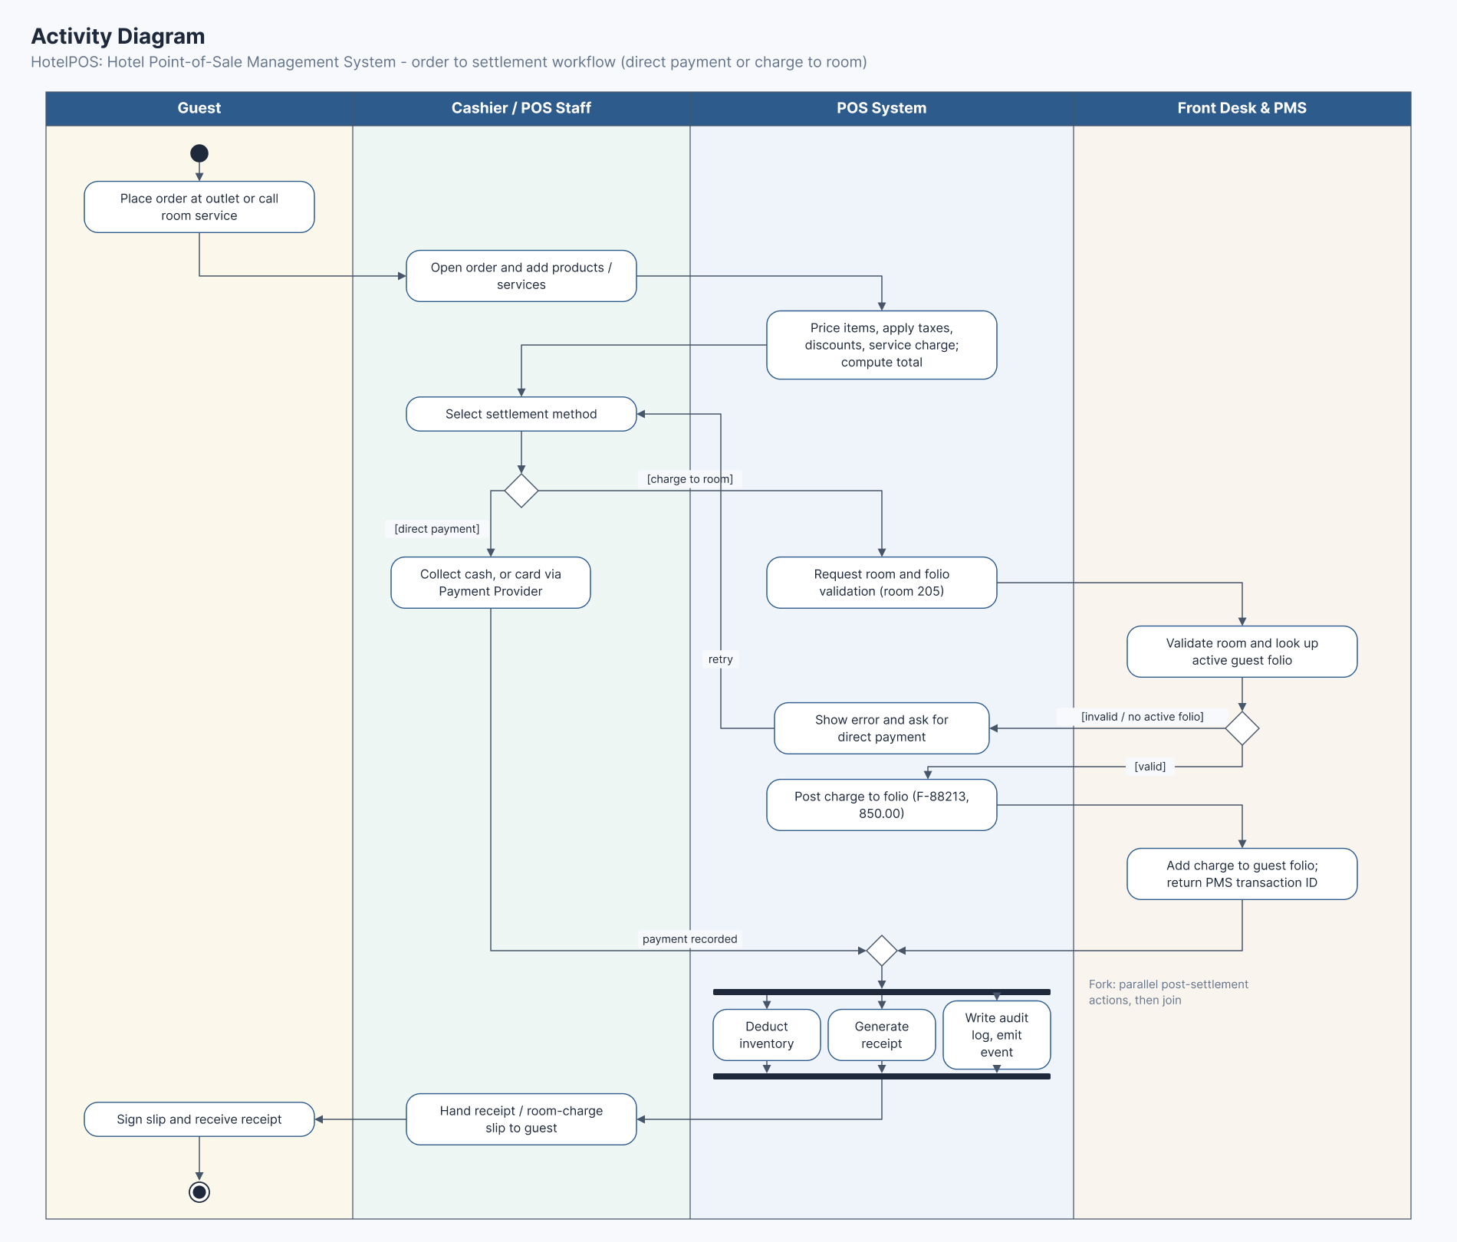
Figure 11: Activity Diagram
The swimlane workflow documents how HotelPOS handles an order from start to finish across the Guest, Cashier/POS Staff, POS System and Front Desk and PMS. The guest places an order at an outlet or calls room service. The cashier opens the order and adds products or services, the POS System prices the items, applies taxes, discounts and service charge and computes the total, and the cashier selects the settlement method. For a direct payment, the cashier collects cash, or card through the payment provider, and the payment is recorded.
For a charge to room, the POS System requests room and folio validation for room 205, and the PMS validates the room and looks up the active guest folio. If the folio is invalid or not active, the system shows an error and asks for a direct payment. If it is valid, the system posts the charge to folio F-88213 for 850.00, and the PMS adds it to the guest folio and returns a transaction ID. Both paths merge, then the system deducts inventory, generates the receipt and writes the audit log in parallel. The cashier hands over the receipt or room-charge slip, and the guest signs it.

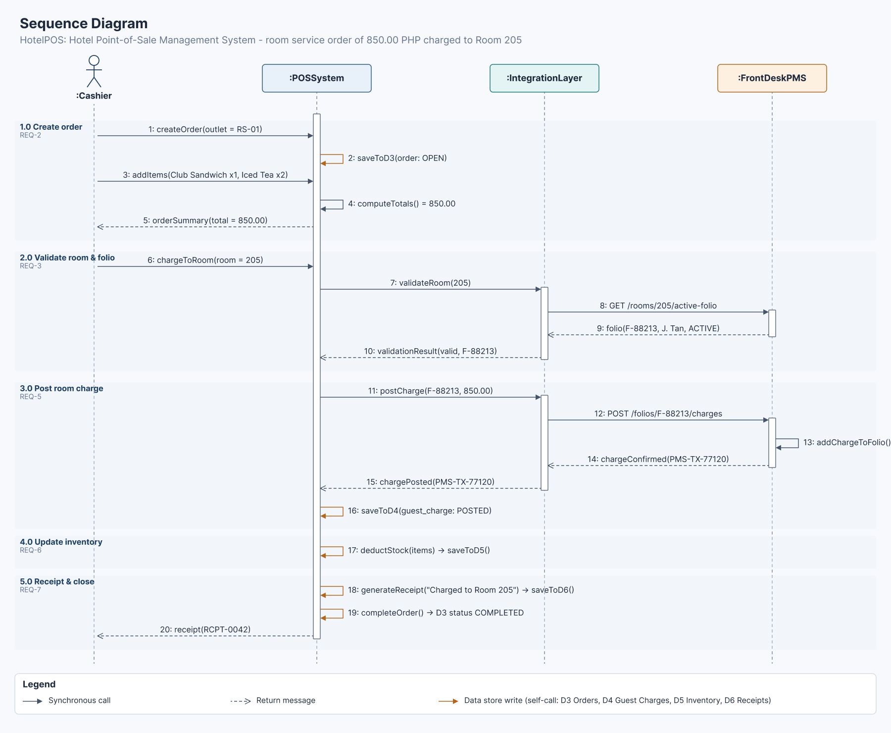
Figure 12: Sequence Diagram
The message sequence lays out how the Room 205 room-service order of 850.00 runs step by step among the Cashier, POS System, Integration Layer and Front Desk PMS, using 20 messages ordered by phase: 1.0 Create Order (steps 1 to 5, REQ-2), 2.0 Validate Room and Folio (6 to 10, REQ-3), 3.0 Post Room Charge (11 to 16, REQ-5), 4.0 Update Inventory (17, REQ-6) and 5.0 Receipt and Close (18 to 20, REQ-7). The cashier creates the order, adds the Club Sandwich and two Iced Teas, receives the 850.00 summary and requests a charge to room 205.
The POS System asks the Integration Layer to validate the room, which calls GET /rooms/205/active-folio on the PMS and returns folio F-88213 as active. The POS then posts the charge, the Integration Layer calls POST /folios/F-88213/charges, and the PMS adds it to the folio and confirms PMS-TX-77120. Solid arrows are calls, dashed arrows are returns, and self-calls such as saveToD3(), saveToD4(), deductStock(), generateReceipt() and completeOrder() are data store writes. The sequence ends with receipt RCPT-0042 returned to the cashier.

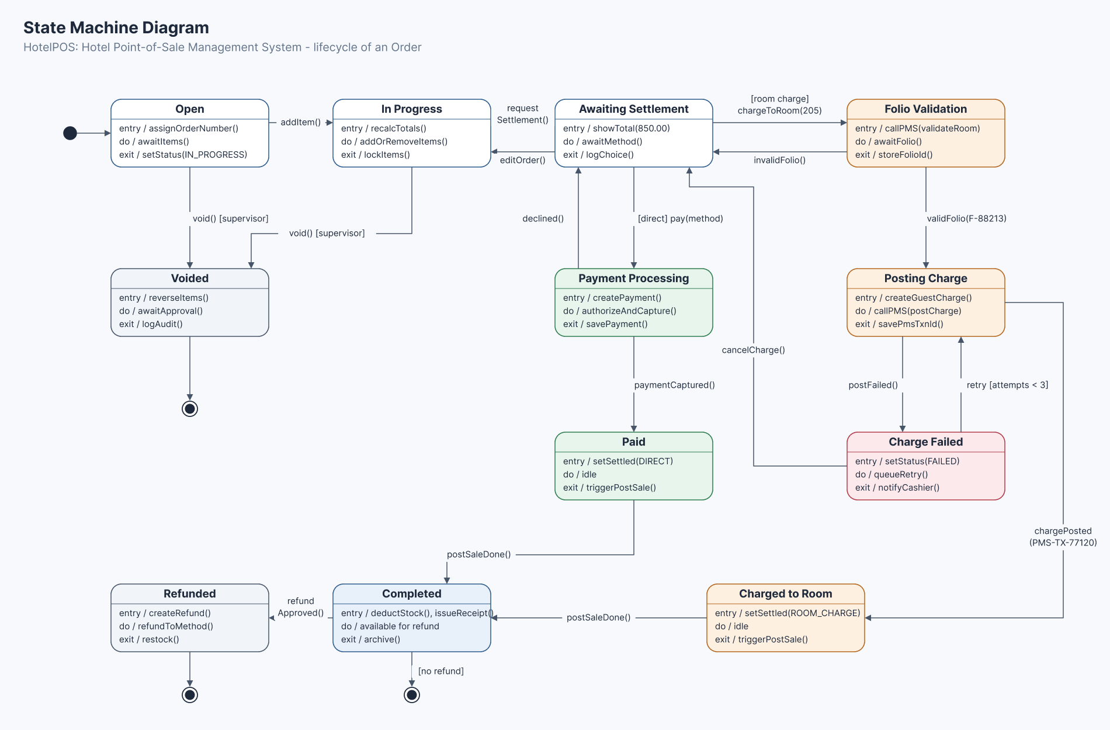
Figure 13: State Machine Diagram
The state machine follows the lifecycle of an Order in HotelPOS, from the moment it is opened to its completion. It starts in Open, becomes In Progress (addItem()) and then Awaiting Settlement (requestSettlement()), and editOrder() returns it to In Progress. For a direct payment, pay(method) moves it to Payment Processing, where declined() returns it to Awaiting Settlement and paymentCaptured() makes it Paid. For a room charge, chargeToRoom(205) moves it to Folio Validation, where invalidFolio() returns it to Awaiting Settlement and validFolio(F-88213) moves it to Posting Charge.
From Posting Charge, chargePosted(PMS-TX-77120) makes the order Charged to Room, while postFailed() moves it to Charge Failed, which can retry up to three times or cancel back to Awaiting Settlement. Paid and Charged to Room both reach Completed on postSaleDone(), which ends the lifecycle unless refundApproved() makes it Refunded. An Open or In Progress order can also be Voided with supervisor approval. Each state has entry, do and exit actions, such as setStatus(), callPMS() and triggerPostSale().

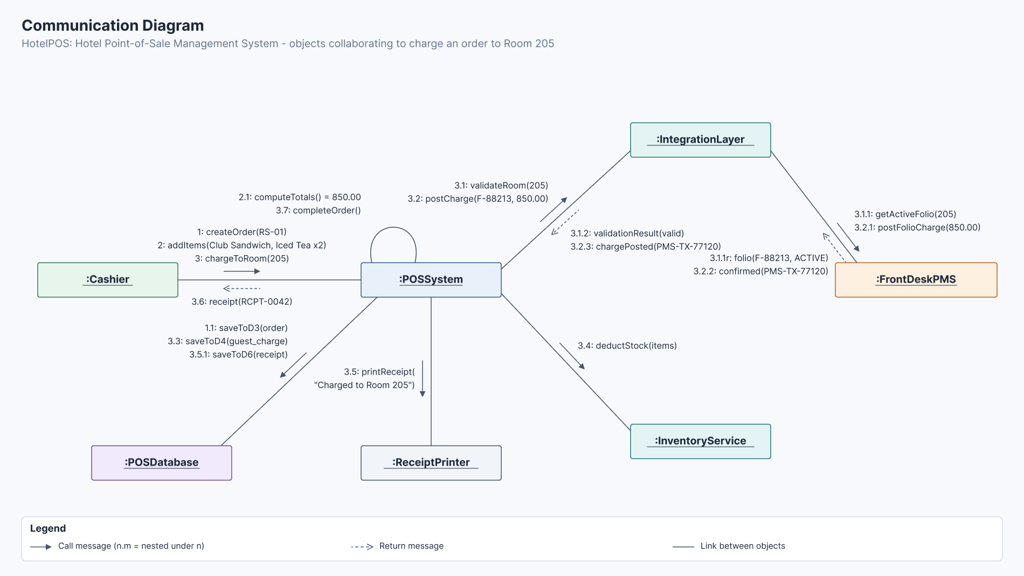
Figure 14: Communication Diagram
The communication view shows which objects work together to charge an order to Room 205: Cashier, POSSystem, IntegrationLayer, FrontDeskPMS, InventoryService, ReceiptPrinter and POSDatabase. The Cashier sends createOrder(RS-01), addItems() and chargeToRoom(205) to the POSSystem, which computes the 850.00 total (2.1) and later completes the order (3.7). The POSSystem calls validateRoom(205) (3.1) and postCharge(F-88213, 850.00) (3.2) on the IntegrationLayer, which calls getActiveFolio(205) (3.1.1) and postFolioCharge(850.00) (3.2.1) on the FrontDeskPMS.
The PMS returns the active folio and the confirmation PMS-TX-77120, and the IntegrationLayer returns the validation result and chargePosted to the POSSystem. The POSSystem then calls deductStock(items) on the InventoryService (3.4), printReceipt("Charged to Room 205") on the ReceiptPrinter (3.5) and saves the order, guest charge and receipt to the POSDatabase (1.1, 3.3, 3.5.1), before returning receipt RCPT-0042 to the cashier (3.6). Numbering shows order; n.m means a message nested under message n, and dashed arrows are return messages.

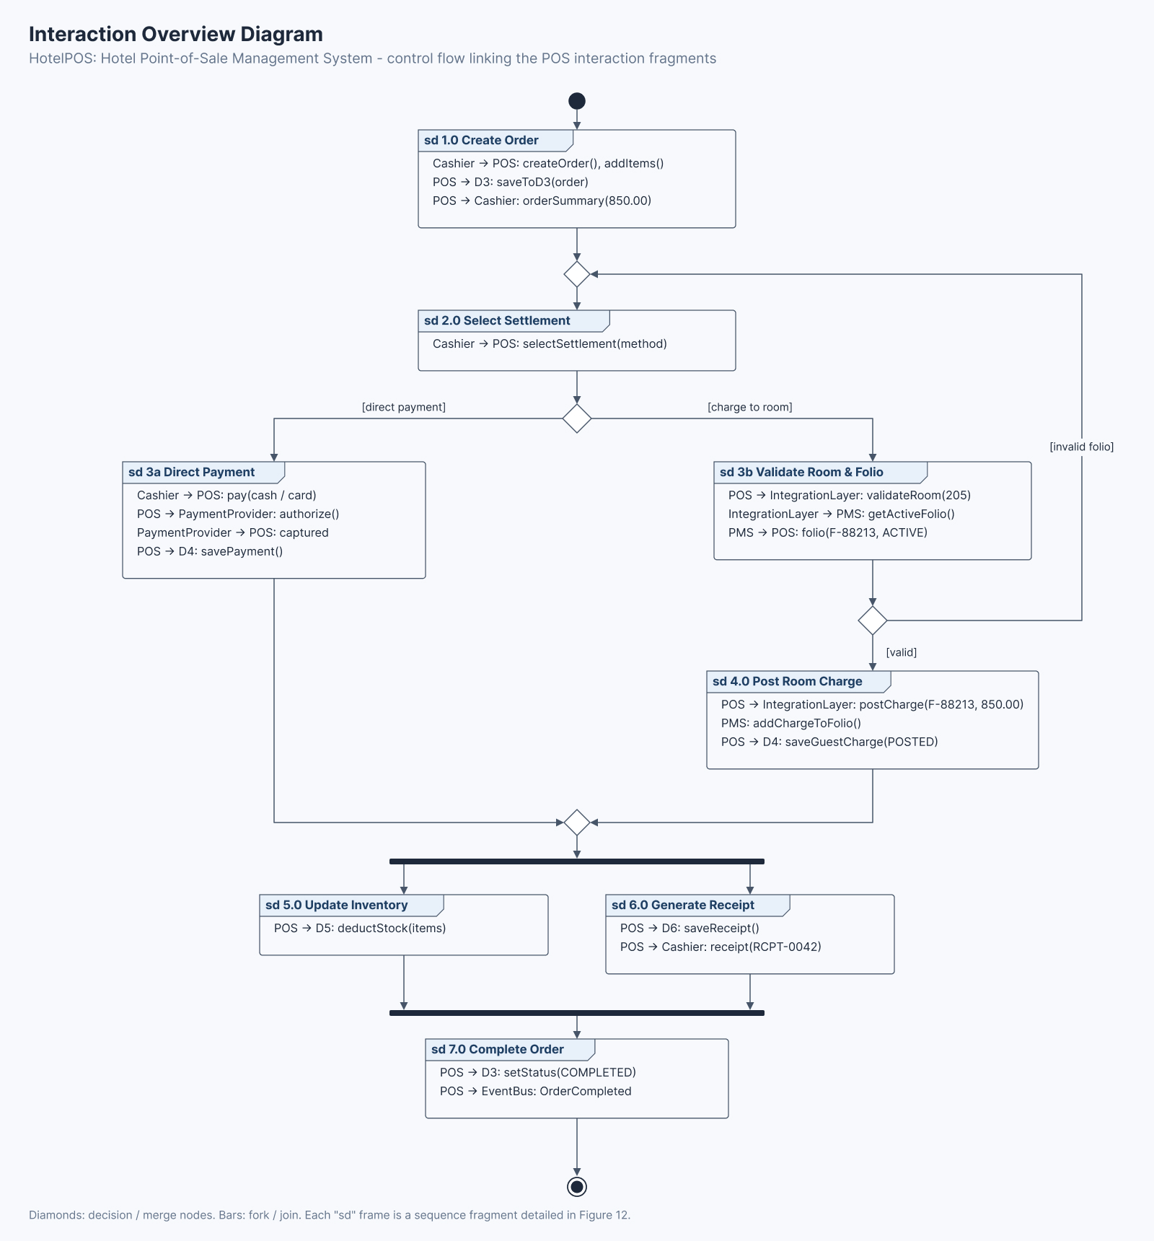
Figure 15: Interaction Overview Diagram
The interaction overview links the HotelPOS sequence frames into one control flow that covers the whole order process. It starts with sd 1.0 Create Order, then reaches a merge node before sd 2.0 Select Settlement. A decision follows: for a direct payment the flow continues to sd 3a Direct Payment, where the payment provider authorizes and captures the payment; for a charge to room it continues to sd 3b Validate Room and Folio. If the folio is invalid, the flow returns through the merge node to Select Settlement; if it is valid, it continues to sd 4.0 Post Room Charge.
Both settlement paths meet at a merge node, and a fork then runs sd 5.0 Update Inventory and sd 6.0 Generate Receipt in parallel. After the join, sd 7.0 Complete Order sets the order status to COMPLETED and publishes an OrderCompleted event, and the flow ends at the final node. Each sd frame is a sequence fragment detailed in Figure 12.

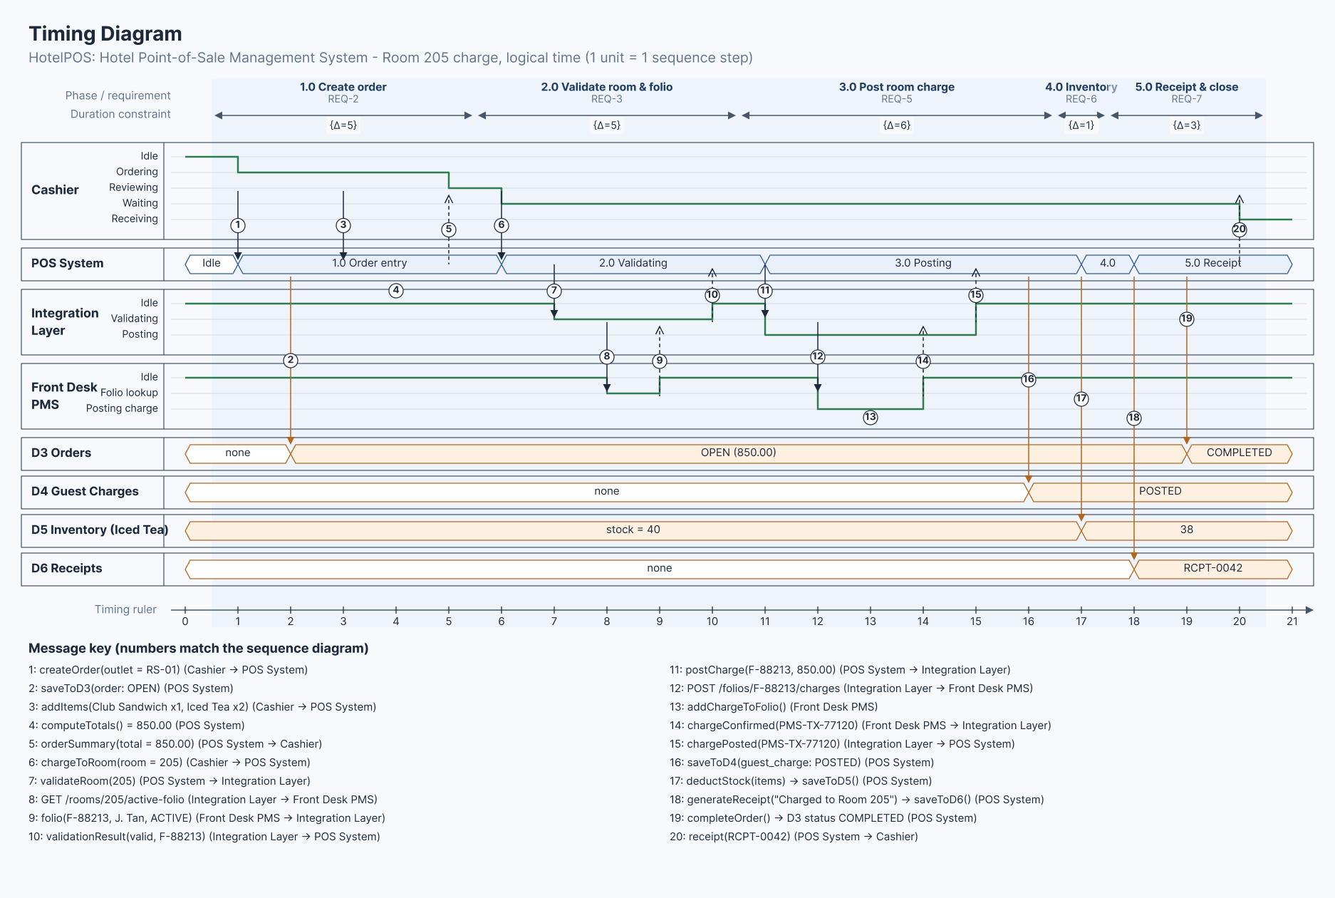
Figure 16: Timing Diagram
The timing view shows how long each stage of the Room 205 charge takes and how the data stores change, plotted on a logical timeline (1 unit = 1 sequence step, t = 0 to 21). Phases carry duration constraints: 1.0 Create Order {Δ=5}, 2.0 Validate Room and Folio {Δ=5}, 3.0 Post Room Charge {Δ=6}, 4.0 Inventory {Δ=1} and 5.0 Receipt and Close {Δ=3}. The Cashier moves from Idle to Ordering, Reviewing, Waiting and Receiving, the Integration Layer moves between Idle, Validating and Posting, and the Front Desk PMS between Idle, Folio lookup and Posting charge.
The POS System's value lifeline moves through Order entry, Validating, Posting, Inventory and Receipt. The data stores change value: D3 Orders from none to OPEN (850.00) at t = 2 and COMPLETED at t = 19, D4 Guest Charges from none to POSTED at t = 16, D5 Inventory (Iced Tea) from 40 to 38 at t = 17, and D6 Receipts from none to RCPT-0042 at t = 18. The numbered messages match the sequence diagram.

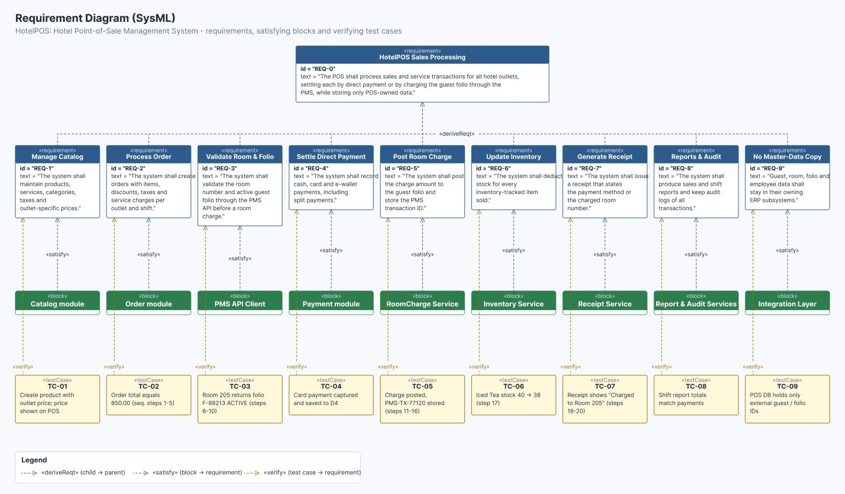

Figure 17: Requirement Diagram (SysML)
The requirements view connects the HotelPOS goals to the parts that deliver them. REQ-0 states that the POS shall process sales and service transactions for all hotel outlets, settling each by direct payment or by charging the guest folio through the PMS, while storing only POS-owned data. It is derived into REQ-1 Manage Catalog, REQ-2 Process Order, REQ-3 Validate Room and Folio, REQ-4 Settle Direct Payment, REQ-5 Post Room Charge, REQ-6 Update Inventory, REQ-7 Generate Receipt, REQ-8 Reports and Audit and REQ-9 No Master-Data Copy.
Each requirement is satisfied by a block: Catalog module, Order module, PMS API Client, Payment module, RoomCharge Service, Inventory Service, Receipt Service, Report and Audit Services, and Integration Layer. Each is verified by a test case, TC-01 to TC-09, several of which are taken from the sequence diagram steps. For example, TC-02 checks that the order total equals 850.00 (steps 1 to 5), TC-05 checks that the charge is posted and PMS-TX-77120 is stored (steps 11 to 16), and TC-09 checks that the POS database holds only external guest and folio IDs.

